**1. What-are-we-going-to-learn-AWS-LBC-Ingress**

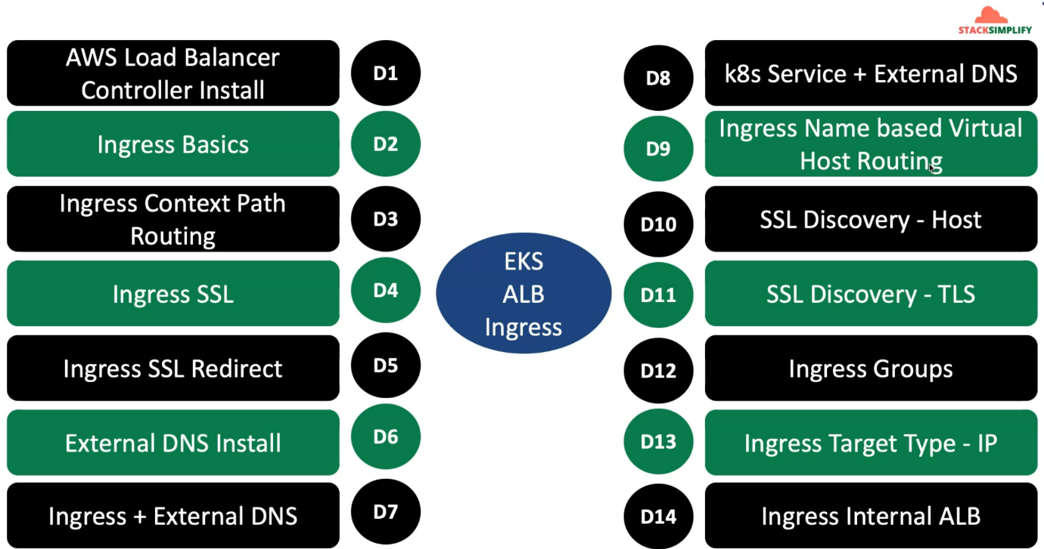

--- **note** – as part of the aws EKS load balancer controller, kubernetes ingress, application load balancer and also external DNS. Consider all these 4 things we are going to implement 14 demos.

--- as part of the demo-1 we are going to install aws load balancer controller.

--- as part of the demo-2 we are going to learn about ingress basics.

--- as part of the demo-3 we will implement context-based routing.

--- in demo-4 and demo-5, we will implement ingress SSL and ingress SSL redirect.

--- **note** – all the demos related to application load balancer.

--- in demo-6, we will install External DNS

--- in demo-7 and demo-8, we will implement ingress, external DNS and k8s service, external DNS.

--- in demo-9, we will implement ingress name based virtual host routing.

--- in demo-10 and demo-11. We will implement SSL Discovery host and SSL Discovery TLS. With hard coding the aws certificate manager and aws arn in your ingress. You can these options.

--- in demo-12, we are going to implement ingress demo groups. A large ingress manifest can split into a small kubernetes manifests. We can create multiple ingress resources and combine them to a single group with a priority order. We are going to learn that in a detail in demo-12.

--- in demo-13, we are going to learn ingress target types. Which is instance mode and target ip mode. So far whatever we implemented, we implemented using instance mode. In this demo we will implement using ip mode.

--- in demo-14, we are going to implement the ingress internal ALB. To test this out, we are going to deploy curl pod.